**Pertemuan 1**

**1. Css1**

**Script**

| 1. <HTML><HEAD>  2. <TITLE> attribute ID</TITLE>  3.<link rel="stylesheet" type="text/css"  4. href="style.css"/>  5.</HEAD>  6.<BODY>  7.<h1>PANTUN</h1>  8.<h2 ID ="Miring">  9. Kalau ada jarum yang patah<BR>  10. Jangan disimpan dalam peti  11.</h2>  12.<h3 ID ="Tebal">  13. Kalau ada kata yang salah<BR>  14. Jangan disimpan dalam hati  15.</h3>  16.</BODY>  17.</HTML> |
| --- |

Screenshot script dan hasil output

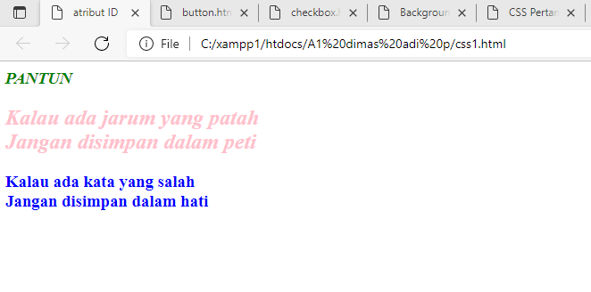

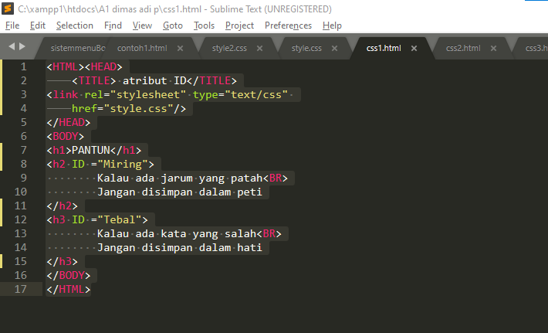

2. Css2

Script

| 1. <HTML> 2. <HEAD> 3. <TITLE>Komentar</TITLE> 4. <STYLE TYPE ="text/CSS"> 6. h3.merah {color: red;} 8. h3.biru {color: blue;} 9. </STYLE> 10. </HEAD> 11. <BODY> 12. <h3 CLASS ="biru"> Biru? Pasti!</H3> 13. <h3 CLASS ="merah"> Merah? Pasti!</H3> 14. <h3 CLASS ="merah"> Merah? Nggak Mungkin!</H3> 15. </BODY> 16. </HTML> |
| --- |

Screenshot script dan hasil output

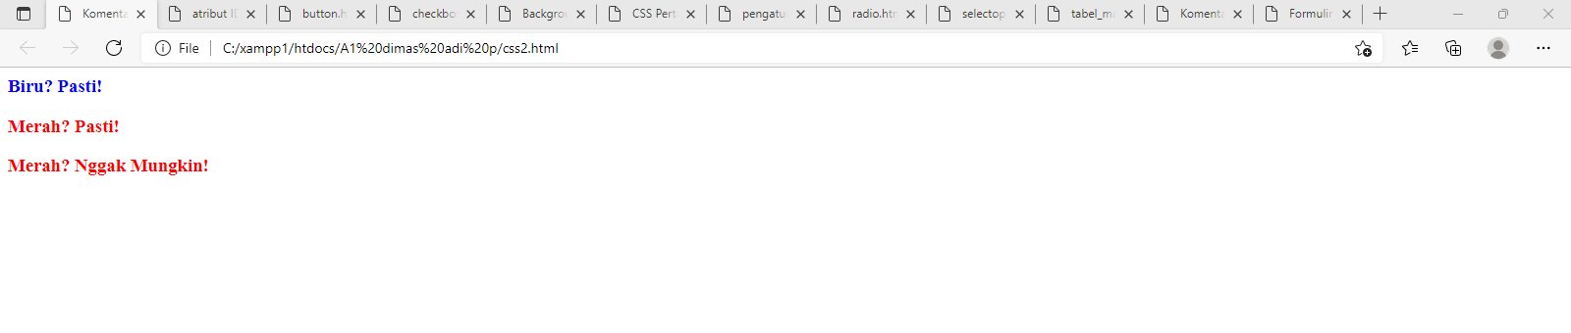

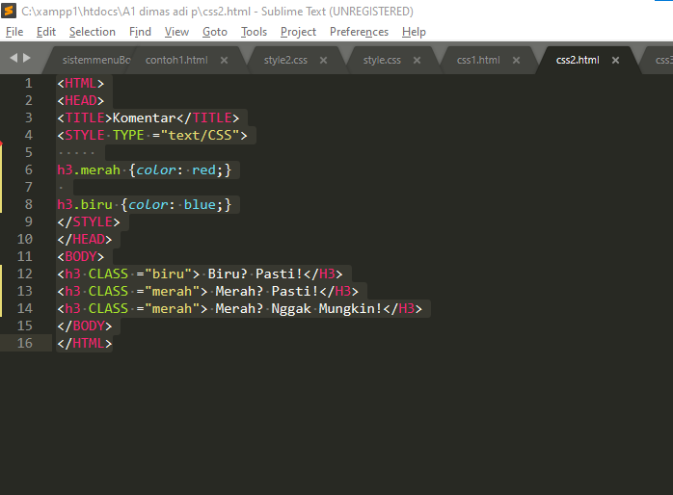

3. Css3

Script

| 1. <HTML> 2. <HEAD> 3. <TITLE>Background-color</TITLE> 4. </HEAD> 5. <BODY> 6. <H2> 7. <SPAN STYLE="color: white; 8. background-color: blue;"> 9. White diatas biru<BR> 10. </SPAN> 11. <SPAN STYLE="color: silver; 12. background-color: black;"> 13. Perak diatas hitam<BR> 14. </SPAN> 15. </H2> 16. </BODY> 17. </HTML> |
| --- |

Screenshot script dan hasil output

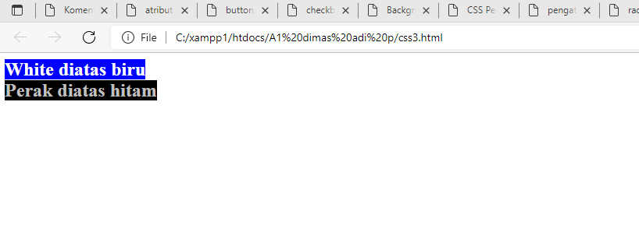

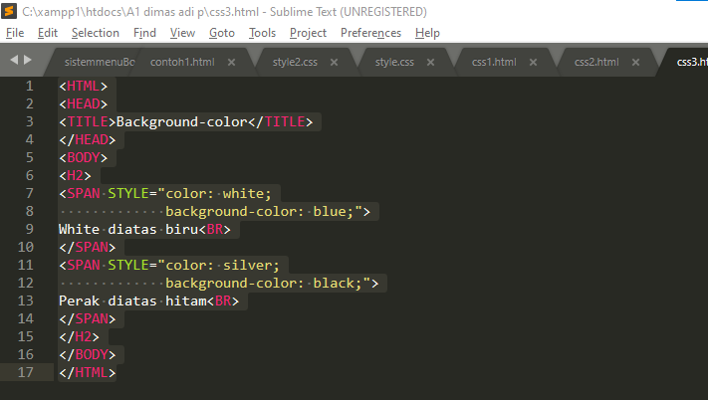

4. Eksternal

Script

| 1. <HTML><HEAD> 2. <TITLE> CSS Pertama</TITLE> 3. <link rel="stylesheet" type="text/css" 4. href="style.css"/> 5. </HEAD> 6. <BODY> 7. <H1>CSS Pertamaku</H1> 8. Selamat mencoba CSS! 9. </BODY> 10. </HTML> |
| --- |

Screenshot script dan hasil output

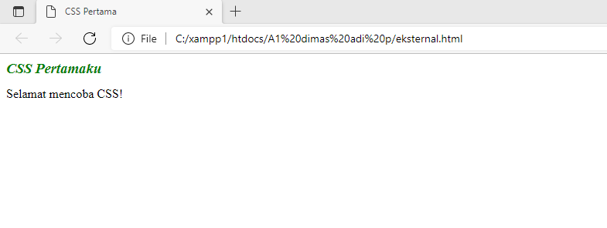

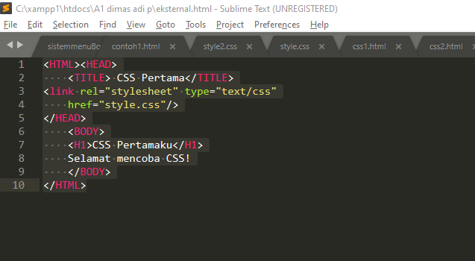

5. Tabel_margin

Script

| 1. <html> 2. <head> 3. <title pengaturan margin></title> 4. <style type="text/css"> 5. table.margin {margin-left:2cm} 6. </style> 7. </head> 8. <body> 9. <p> 10. paragraf tidak diberi margin 11. </p> 12. <table class="margin" width="50%" border="1"> 13. <tr> 14. <td>perataan margin kiri</td> 15. </tr> 16. <tr> 17. <td>&nbsp;</td> 18. </tr> 19. </table> 20. </body> 21. </html> |
| --- |

Screenshot script dan hasil output

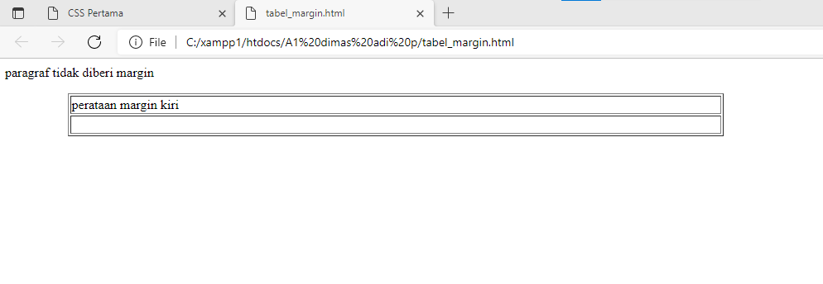

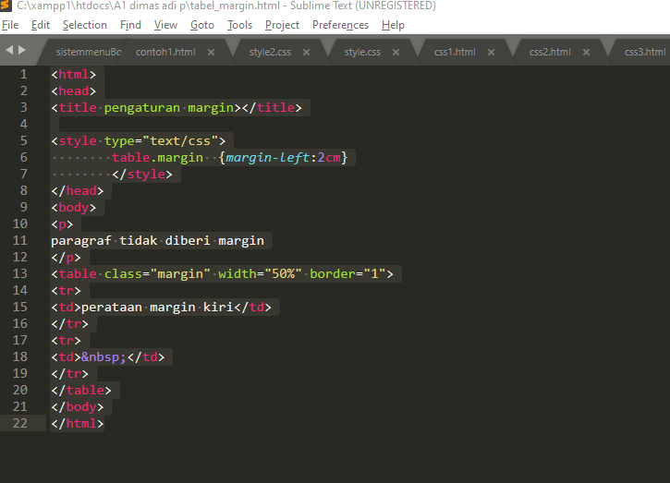

6. Button

Script

| 1. <!DOCTYPE html> 2. <html> 3. <body> 4. <h3> Pilih makanan </h3> 5. <form> 6. <input type="button" value="nasi goreng"> <br> 7. <input type="button" value="mie ayam"> <br> 8. <input type="button" value="bakso"> <br> 9. <input type="button" value="soto ayam"> <br> 10. <br> 11. <input type="submit" value="submit"> 12. </form> 13. </body> 14. </html> |
| --- |

Screenshot script dan hasil output

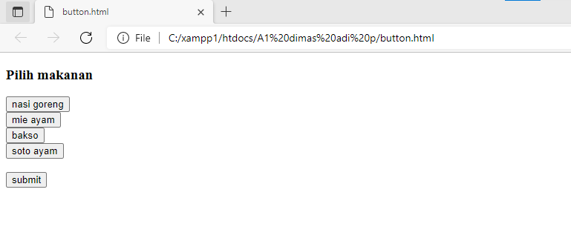

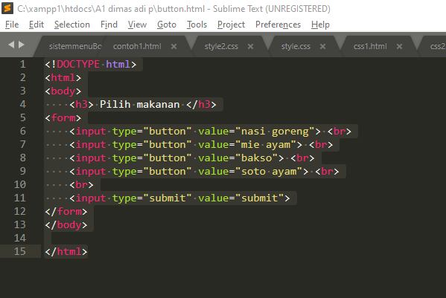

7. Checkbox

Script

| 1. <!DOCTYPE html> 2. <html> 3. <body> 4. <h3> kendaraan apa yang anda miliki ? </h3> 5. <form> 6. <input type="checkbox" value="mobil"> mobil <br> 7. <input type="checkbox" value="motor"> motor <br> 8. <input type="checkbox" value="sepeda"> sepeda <br> 9. <input type="checkbox" value="pesawat"> pesawat <br> 10. <br> 11. <input type="submit" value="submit"> 12. </form> 13. </body> 14. </html> |
| --- |

Screenshot script dan hasil output

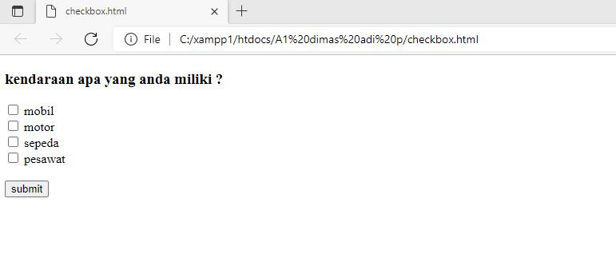

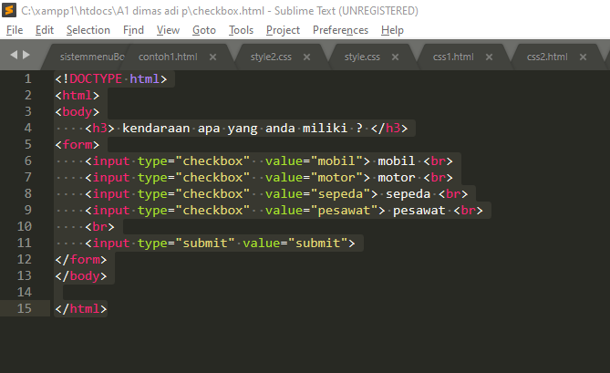

8. Radio

Script

| 1. <!DOCTYPE html> 2. <html> 3. <body> 4. <h3> Pilih jenis kelamin </h3> 5. <form> 6. <input type="radio" nama="gender" value="laki-laki"> laki-laki <br> 7. <input type="radio" nama="gender" value="perempuan"> perempuan <br> 8. <input type="radio" nama="gender" value="lainnya"> lainnya <br> 9. <input type="submit" value="submit"> 10. </form> 11. </body> 12. </html> |
| --- |

Screenshot script dan hasil output

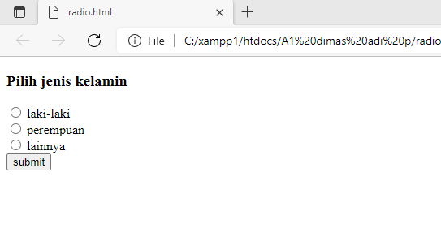

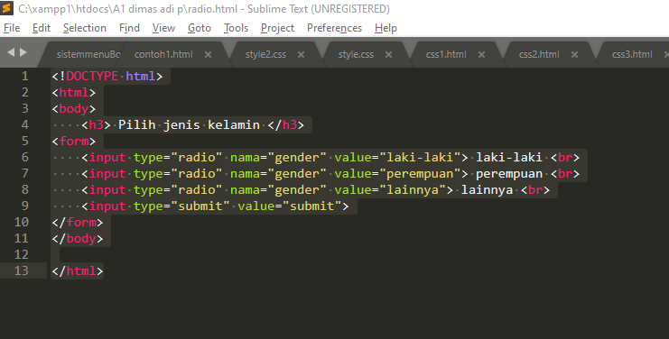

9. Select option

Script

| 1. <!DOCTYPE html> 2. <html> 3. <body> 4. <h3> kendaraan apa yang anda miliki ? </h3> 5. <form> 6. <select> 7. <option type="checkbox" value="mobil"> mobil </option> 8. <option type="checkbox" value="motor"> motor </option> 9. <option type="checkbox" value="sepeda"> sepeda </option> 10. <option type="checkbox" value="pesawat"> pesawat </option> 11. </select> 12. <br><br> 13. <input type="submit"> 14. </form> 15. </body> 16. </html> |
| --- |

Screenshot script dan hasil output

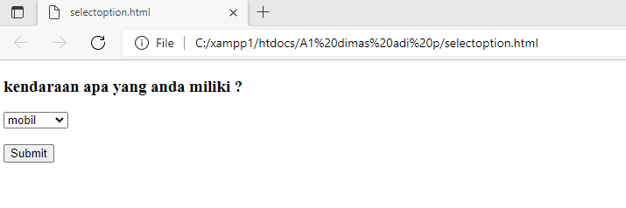

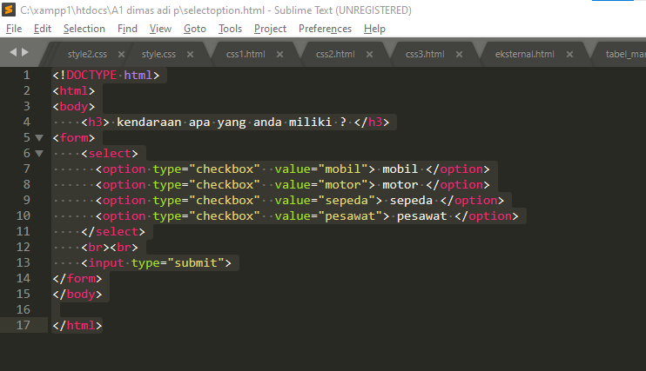

10. fm_btnflat

Script

| 1. <html> 2. <head> 3. <title> pengaturan pada form tombol </title> 4. <style type="text/css"> 5. input.button 6. { 7. color: #000000; 8. background: red; 9. background-color: white; 10. border-bottom-color: green; 11. border-top:2px dotted; 12. border-bottom:1px dotted; 13. border-left:1px dotted; 14. border-right:1px dotted; 15. font-family: verdana; 16. font-size:12px; 17. } 18. </style> 19. </head> 20. <body> 21. <form name ="forml" method="post" action=""> 22. <table bordercolor="1"> 23. <tr> 24. <td width="58">nama</td> 25. <td width="230">: 26. <input type="text" name="nama"> 27. </td> 28. </tr> 29. <tr> 30. <td width="58">alamat</td> 31. <td width="230">: 32. <input type="text" name="alamat"> 33. </td> 34. </tr> 35. <tr> 36. <td></td> 37. <td> 38. <input class="button" type="submit" 39. name="submit" value="simpan"> 40. <input class="button" type="submit" 41. name="submit2" value="submit"> 42. </td> 43. </tr> 44. </table> 45. </form> 46. </body> 47. </html> |
| --- |

Screenshot script dan hasil output

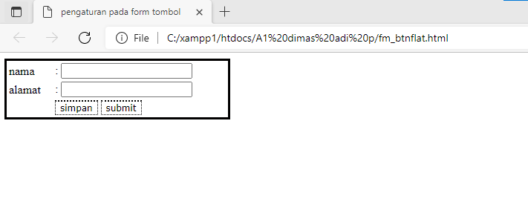

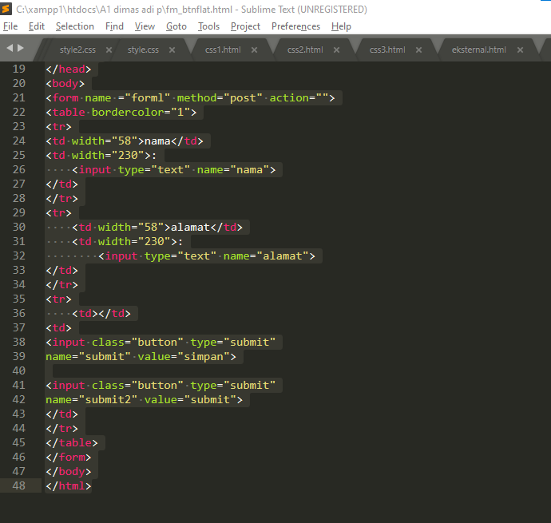

11. lat_css

Script

| 1. <HTML> 2. <TITLE> CSS Pertamaku </TITLE> 3. <STYLE TYPE = "text/CSS"> 4. <!-- 5. h1 { font-size:14pt; 6. font-style: italic; 7. color: green; } 8. --> 9. </STYLE> 10. </HEAD> 11. <BODY> 12. <h1> CSS Pertamaku</h1> 13. Selamat mencoba CSS! 14. </BODY> 15. </HTML> |
| --- |

Screenshot script dan hasil output

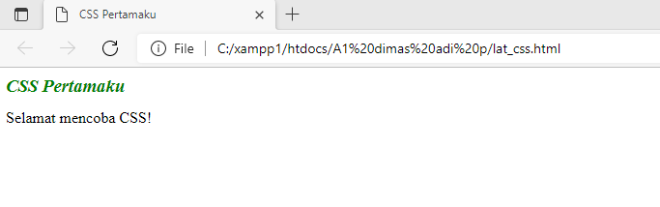

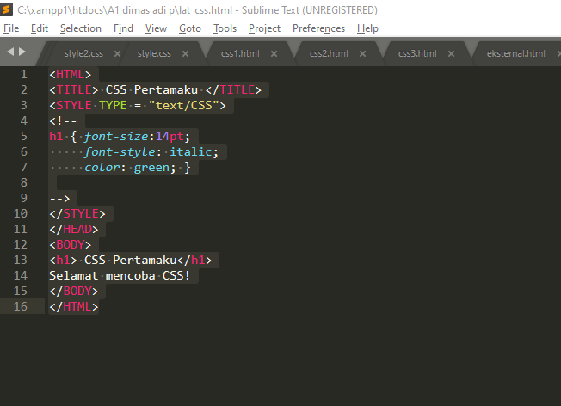

**TUGAS**

Script

| 1. <HTML><HEAD> 2. <TITLE> Formulir Registrasi</TITLE> 3. <link rel="stylesheet" type="text/css" 4. href="style2.css"/> 5. </HEAD> 6. <BODY> 7. <H1>SELAMAT DATANG</H1> 8. <H2>FORMULIR REGISTRASI</H2> 10. <table> 11. <tr> 12. <td>Nama Lengkap</td> 13. <td>:</td> 14. <td><input type="text"></td> 15. </tr> 16. <tr> 17. <td>Tempat Lahir</td> 18. <td>:</td> 19. <td><input type="text"></td> 20. </tr> 21. <tr> 22. <td>Tanggal Lahir</td> 23. <td>:</td> 24. <td><input type="Date"></td> 25. </tr> 26. <tr> 27. <td>Jenis Kelamin</td> 28. <td>:</td> 29. <td><input type="radio" name='jenis_kelamin' value='pria'/>Pria 30. <input type="radio" name='jenis_kelamin' value='perempuan'/>Perempuan</td> 31. </tr> 32. <tr> 33. <td>Alamat</td> 34. <td>:</td> 35. <td><textarea cols="22" rows="3" ></textarea></td> 36. </tr> 37. <tr> 38. <td>Kota</td> 39. <td>:</td> 40. <td><select> 41. <option>*****SELECT KOTA*****</option> 42. <option>Bogor</option> 43. <option>Jakarta</option> 44. <option>Bekasi</option> 45. <option>Tangerang</option> 46. <option>Depok</option> 47. <option>Cikarang</option> 48. <option>Banten</option> 49. </select></td> 50. </tr> 51. <tr> 52. <td>No Hp</td> 53. <td>:</td> 54. <td><input type="number"></td> 55. </tr> 56. <tr> 57. <td>E-mail</td> 58. <td>:</td> 59. <td><input type="email"></td> 60. </tr> 61. <tr> 62. <td>&nbsp;</td> 63. <td>&nbsp;</td> 64. <td><input type="submit" name="submit" value="Simpan"/> 65. <input type="reset" name="reset" value="Batal" /></td> 66. </tr> 67. </table> 68. </BODY> 69. </HTML> |
| --- |

Screenshot script dan hasil output

